Prototype Rail Types
At first glance there are three options for prototyping our rail system, clear acrylic sheets, 3d printing and using premade struts. Each of these options have pros and cons for use within out UAV launcher's design. This document outlines each option and weighs the advantages and disadvantages to come up with a final decision.

Clear Acrylic Sheets:
Clear acrylic sheets come in many sizes; the sizes that are both in our budget and big enough for our rail system are 0.08x24x48 inch and 0.118x24x48 inch sheets. These acrylic sheets are easily available at local hardware stores.
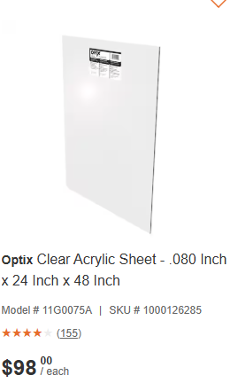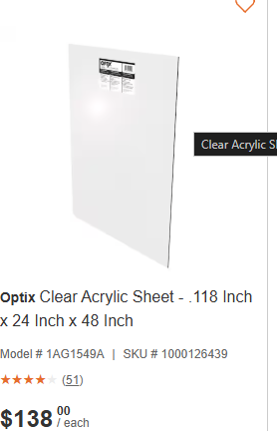
Figure 1: Clear Acrylic Sheet Options

Bending
The best way to fabricate our rails from acrylic is to bend it into the shape using heat. This allows us to get the shape of our rail without having to use fasteners, which would add weak points and potentially interfere with the launch of our UAV. However, bending acrylic can be difficult to execute properly, with high chance of error the cost of this option increases with each attempt. These links show and explain how to properly bend acrylic. A jig would be required in order to ensure consistent and proper shape.
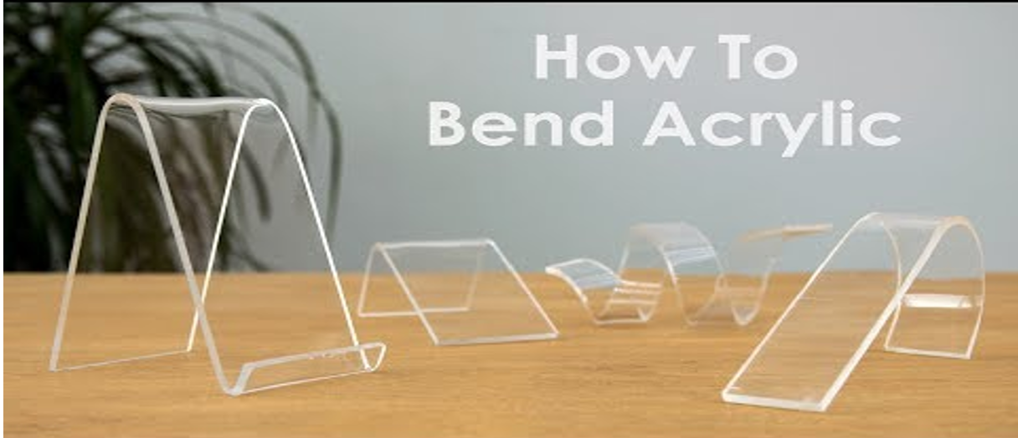
Figure 2: Bent Acrylic

Laser Cutting
Acrylic sheets are able to be laser cut allowing us to accurately cut our sheets the desired size for our rail as well as cut out any water drainage before shaping the sheets. Laser cutting is available in the ILC for a cost depending on the size of the part.

Cost
One sheet of 24x48inch acrylic should be enough to fabricate both rails not accounting for error. Sheets of 0.08- and 0.118-inch thickness cost 98 and 138 dollars respectively. In addition, the cost of laser cutting is added to the total cost. This method of fabrication is bound to have errors during manufacturing, increasing the total cost exponentially each time.

Pros
- The molded acrylic allows for the rail to be constructed of one continuous piece
- The fiction within the rail is lower with the smooth acrylic
- Laser cutting allows for easy addition of water drainage holes

Cons
- Difficult to fabricate properly
- High likelihood of error
- Expensive in the inevitable event of errors

3D Printed PLA:
In the case of 3D printing, the rail would be constructed in sections with dowel holes allowing each segment to be attached together. A rough cross-sectional image is shown below.

Figure 3: 3D Printed Rail Coss Section
This method would require each rail to consist of multiple parts. This adds seams at the connection points where the launch could potentially get caught up on, interfering with the launch. In addition, each seam is a weak point where stress from the force exerted by the launch or the waves could end in structure failure.
This method provides our team with the greatest freedom in our design, allowing us to make the exact shape we want. However, with this method there is the issue of overhang while printing; this will require us to manually drill the drainage holes after printing is complete.
PLA has a tensile strength of 50-60 MPa compared to a tensile strength of 65 MPa and flexural strength of 90MPa for acrylic. The layers of 3D printed PLA lead to weak points in the layers when bending.

Cost
3D printing filament is roughly 30 dollars a roll. Assuming that we would need 3-4 rolls to construct both of the rails with room for error and redesign the total cost would be ~90-120 dollars.

Pros
- Customizability
- The costs are lower than that of acrylic
- Ease of fabrication

Cons
- Multiple sections increasing the number of week points and catch hazards.
- 3D Printed PLA even at 100% fill is the weakest option, with the lowest tensile and flexural strength.
- Higher friction compared to acrylic

Atkore Sasco Strut:
The version of the Atkore Sasco Strut we are considering is the S2 SL2-G 120 alongside the S875T-EG Trolley.

S2
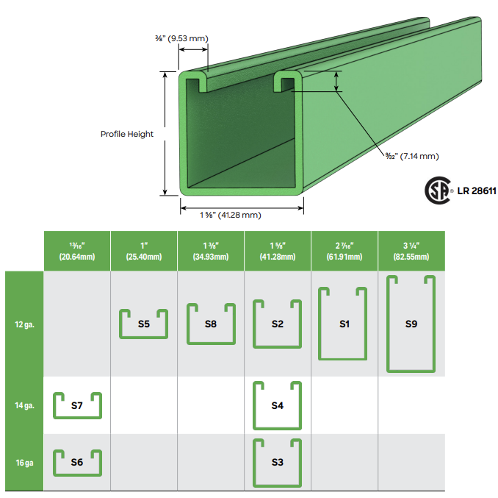
Figure 4: S2 Channel
Table 1: Channel Specifications
Height | 1-5/8 in
Width | 1-5/8 in
Steel Thickness | 12 gauge

Using these channels as the base of our rails allows the rails to be made from one solid piece without the need for as much fabrication as using acrylic or PLA 3D printing. In addition, these channels provide us a greater amount of stability compared to the other options due to it being made from solid steel. This stability increase allows our system to function more consistently.

Slotted:
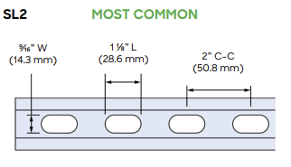
Figure 5: SL2 Slotting
The slots in the strut in our case allow the water trapped inside the rail to have places to run out, preventing the rail from trapping an excess amount of water.

-G
These struts are made from galvanized steel; this is due to what is available to us within our budget. It would be much better if we were able to use stainless steel instead due to its improved corrosion resistance as well as its higher tensile strength of 515- 1300 MPa compared to 400-841MPa for galvanized steel.

120
This states that the strut is 120 inches long or 10 feet; this allows us to have plenty of room to cut our rails to the appropriate size as well as having excess in the case of error.

Atkore Sasco Strut S875T-EG Trolley
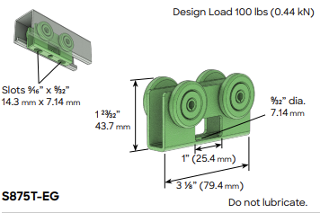
Figure 6: S875T-EG Trolley
The S875T-EG trolly is designed to be seamlessly compatible with the S2 strut. The structure of the trolly is made from electrogalvanized steel with stainless steel wheel bearings that require no lubrication. The trolley is rated for 100lbs of load. In addition to working seamlessly with the struts these trolleys allow us to have a solid and stable base to attach our carriage system as well as deliver the force required to launch.
Cost
The S2 SL2-G 120 strut channel and the S876T-EG trolley are typically sold from industrial supply distributors, and individual pricing is hard to obtain. In our case, a group member has access to excess from work costing our team nothing.
Pros:
- These channels are the most structurally sound option
- There is less fabrication in order to implement this into our design, all that is required is to cut them to the proper size.
- There are trolleys specifically designed for these channels
- Group member has access to supply for minimal to no cost
- Come slotted allowing for water drainage
Cons:
- These channels being made from steel weigh more than the other options which in turn puts a greater burden on the angle control actuators.
- Galvanized steel; the galvanized steel will over time corrode and rust compared to if stainless steel were to be used.
- Higher friction compared to acrylic.

Final Decision
The best option for use in our marine UAV launcher is the Atkore Sasco Strut with the S875T-EG Trolley. This option along with costing our group nothing provides the best structure allowing for the most consistent launching. The S875T-EG trolley allows us to save time designing a trolly system as well as providing a stable platform to securely attach our carriage design. Compared to the other two options the strut requires the least amount of manufacturing; this frees our group up to put more time into the other aspects of design problem.

References
[1] Plexiglass & acrylic sheets - building materials - homedepot.ca, https://www.homedepot.ca/en/home/categories/building-materials/plexiglass-and-acrylic-sheets.html.
[2] “The ultimate guideline of bending acrylic,” UVACRYLIC, https://uvacrylic.com/blog/bend-acrylic-sheet/.
[3] YouTube, https://www.youtube.com/watch?v=s5nP7MDf63Y&t=1s.
[4] “What is the strongest 3D printing material? A complete guide to material strength,” Formlabs, https://formlabs.com/blog/strongest-3d-printing-materials/.
[5] C. Ellis, “Everything about acrylic plastics,” McNeall Plastics, https://www.mcneallplastics.com.au/news/everything-about-acrylic-plastics.
[6] “1.75mm PLA filament - translucent - 1 kg,” Translucent PLA 3D Printer Filament 1.75mm Kingston Ontario Canada, https://store.qkits.com/1-75mm-pla-filament-translucent-1-kg.html.
[7] Struts and accessories from atkore., https://sascostrut.com/application/files/5916/4986/4782/Catalogue_2.21_-_Web.pdf.
[8] “Galvanized Steel vs. Stainless Steel,” Unified Alloys, https://www.unifiedalloys.com/blog/stainless-steel-vs-galvanized/.
[9] “Sasco Strut 4 wheel trolley - double-axle, 100 lbs,” Electrical Cable Management, Safety, & Infrastructure Solutions, https://www.atkore.com/en-ca/product/s875t-eg.

